**Bug Resolution Application Management**

**(Web Application)**

**Technologies: Django**

HEART DISEASE DIAGNOSTIC ANALYSIS 2

Contents

Document Version Control 2

1. Introduction 4
   1. What is Low Level Design Document? 4
   2. Scope… 4
   3. Project Introduction 4
2. Problem Statement 5
3. Architecture 7
4. Architecture Description 8

# Introduction

## What is Low Level Design Document?

The goal of the Low-level design document (LLDD) is to give the internal logic design of the actual program code for the Heart Disease Diagnostic Analysis dashboard. LLD describes the class diagrams with the methods and relationsbetween classes and programs specs. It describes the modules so that the programmer can directly code the program from the document.

## What is Scope?

Low-level design (LLD) is a component-level design process that follows a step-by-step refinement process. The process can be used for designing data structures, required software architecture, source code, and ultimately, performance algorithms. Overall, the data organization may be defined duringrequirement analysis and then refined during data design work.

## Project Introduction

As we Know the IT technology is growing up day by day. And with the advancement in technology users facing issues while learning this technologies. There are many communities where users post there questions/queries and get answer related to these questions. The main example of this type of community is stack over flow. So in this project created a bug resolution app using Django. Where developers post there queries and other developers answers there questions

# Problem Statement

The goal of this project is to make a website where user post there questions and other people answers there questions. A web application where developers can suggest the solution for any specific issue.

# Daigram:

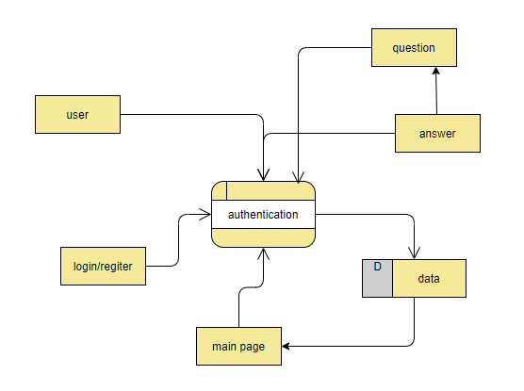

# Architecture overview:

# Authentication:

For every user that want to post question or do extra activities in this system like voting updating, deletion or answering question must be login to the system

# Question:

User can post there question so other user can answer there question vote it and can comment on this question

# Answer:

User can post there answer to a specific question and other user can comment there answer vote it.